DESIGN AND IMPLEMENTATION OF
EMPLOYEE INFORMATION SYSTEM

Form: employee details

SQL> desc emp;
Name Null? Type
----------------------------------------- -------- ----------------------------
EMPNO NOT NULL NUMBER(4)
ENAME VARCHAR2(10)
JOB VARCHAR2(9)
MGR NUMBER(4)
HIREDATE DATE
SAL NUMBER(7,2)
COMM NUMBER(7,2)
DEPTNO NUMBER(2)

Form design:

Input Form
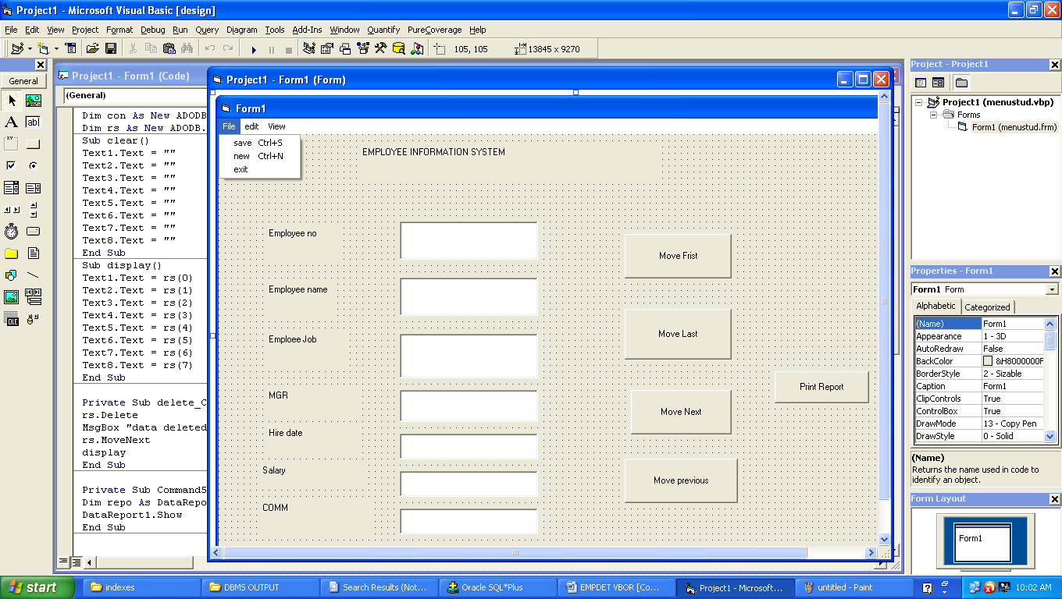

CODING:

Dim con As New ADODB.Connection
Dim rs As New ADODB.Recordset

Sub clear()
Text1.Text = ""
Text2.Text = ""
Text3.Text = ""
Text4.Text = ""
Text5.Text = ""
Text6.Text = ""
Text7.Text = ""
Text8.Text = ""
End Sub

Sub display()
Text1.Text = rs(0)
Text2.Text = rs(1)
Text3.Text = rs(2)
Text4.Text = rs(3)
Text5.Text = rs(4)
Text6.Text = rs(5)
Text7.Text = rs(6)
Text8.Text = rs(7)
End Sub

Private Sub add_Click()
clear
Text1.SetFocus
End Sub

Private Sub delete_Click()
rs.delete
MsgBox "data deleted"
rs.MoveNext
display
End Sub

Private Sub exit_Click()
MsgBox ("thank u")
End
End Sub

Private Sub Form_Load()
con.Open "xxx", "scott", "tiger"
rs.Open "select * from emp", con, adOpenDynamic, adLockPessimistic
rs.MoveFirst
End Sub

Private Sub save_Click()
rs.MoveLast
rs.AddNew
rs(0) = Text1.Text
rs(1) = Text2.Text
rs(2) = Text3.Text
rs(3) = Text4.Text
rs(4) = Text5.Text
rs(5) = Text6.Text
rs(6) = Text7.Text
rs(7) = Text8.Text
rs.Update
display
MsgBox "Record Saved"
clear
End Sub

Private Sub view_Click()
Text1.Text = rs(0)
Text2.Text = rs(1)
Text3.Text = rs(2)
Text4.Text = rs(3)
Text5.Text = rs(4)
Text6.Text = rs(5)
Text7.Text = rs(6)
Text8.Text = rs(7)
End Sub

Private Sub movefirst_Click()
rs.movefirst
display
End Sub

Private Sub movelast_Click()
rs.movelast
display
End Sub

Private Sub moveprevious_Click()
rs.moveprevious
If rs.BOF = True Then
rs.movelast
display
Else
display
End If
End Sub

Private Sub movenext_Click()
rs.movenext
If rs.EOF = True Then
rs.movefirst
display
Else
display
End If
End Sub

Private Sub modify_Click()
rs(0) = Text1.Text
rs(1) = Text2.Text
rs(2) = Text3.Text
rs(3) = Text4.Text
rs(4) = Text5.Text
rs(5) = Text6.Text
rs(6) = Text7.Text
rs(7) = Text8.Text
rs.Update
MsgBox "record modified"
End Sub

Private Sub find_Click()
Dim w As Integer
w = InputBox("enter the employee number")
On Error GoTo er
rs.find "accno=" & w, adSearchForward
display
Exit Sub
er:
clear
MsgBox "record not found"
End Sub

Private Sub printreport_Click()
Dim repo As DataReport1
DataReport1.Show
End Sub

